

Submitted by: Iram Mehboob
Submitted to: Mam Nayab Khalid
Sap id: 73644
Subject: data structure and algorithm
Date: 9/16/2026

Task 01:
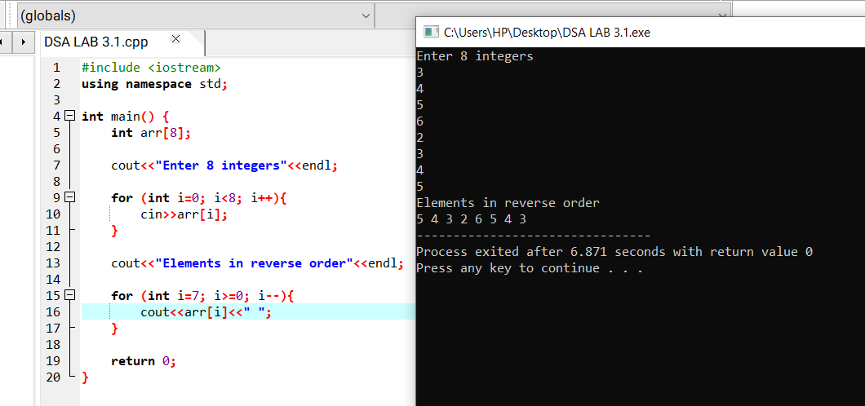Task 02:
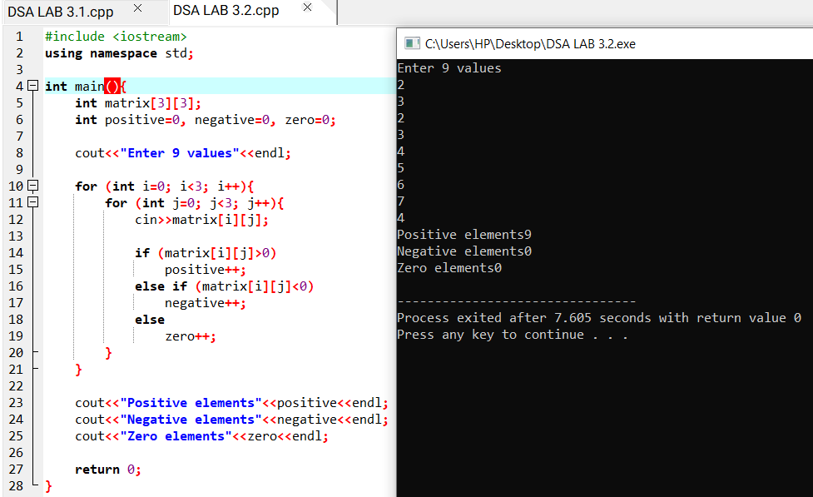

Task 03:


